October monthly report
……..........................................................
Dr. Pongkarn Chakthranont
โครงการ P2451496 งบยุทธ_CCU68_การต่อยอดและพัฒนาเทคโนโลยี Carbon capture and utilization (CCU) ที่มีความต้องการจากภาคอุตสาหกรรม และขับเคลื่อน National CCUS Alliance ร่วมกับเครือข่ายพันธมิตร
Sothearoth Heng
Under the supervision of
Dr. Pongkarn Chakthranont
ใบสั่งจ้างเลขที่ PO25005060
จ้างเหมาพัฒนางานจ้างพัฒนาการขยายขนาดเซลล์ไฟฟ้าเพื่อการผลิตแก๊สสังเคราะห์จาก CO₂ เชิงเคมีไฟฟ้า
งวดที่ 7: 1 October 2568 – 30 October 2568

- To-do list in October
  - 100cm² MEA electrolyzer – CO₂ electrolysis of serpentine-BPM system under a dried 200ml/min CO₂, 100ml/min of 0.25M KOH, and IrO₂-TiPt anode at 100mA/cm²
  - 100cm² MEA electrolyzer – CO₂ electrolysis of serpentine-BPM system under a humidified 200ml/min CO₂, 100ml/min of 0.25M CsOH, and IrO₂-TiPt anode at 100mA/cm²
- Experimental Procedure
Synthesis of NiSAC by pyrolysis method
The synthesis of NiSAC catalyst was followed by our previous work. Initially, nickel phthalocyanine (NiPc), urea, and dicyanamide precursors were stoichiometrically weighed according to mass ratios of x:5:5, wherein urea and dicyanamide were maintained at 5 g each while varying the NiPc content (x = 0.25, 0.5, 1.0, and 2.0 g). Subsequently, the mixture was thoroughly mixed and ground until a homogeneous midnight blue powder was obtained. The fine powder was then transferred into a quartz boat covered with a capsule lid and subjected to polymerization at 800 °C (ramp rate = 10 °C·min⁻¹) in a horizontal tube furnace under an argon atmosphere (flow rate = 200 sccm) for 2 h. The as-prepared xNiSAC catalysts with different NiPc contents were finally obtained and labeled as 0.25NiSAC, 0.5NiSAC, 1.0NiSAC, and 2.0NiSAC.

Fabrication of IrO₂/TiPt felt anode electrode
The IrO₂/TiPt-felt anode electrode was prepared using a thermal deposition method involving multiple sequential steps. Initially, the TiPt felt (Purchased from ...) substrate was ultrasonically cleaned with deionized water and acetone to remove any surface contaminants. The cleaned substrate was subsequently etched in a 6M HCl solution at 90°C for 45 min to enhance surface roughness and adhesion properties. The dip-coating solution was prepared by dissolving 200 mg of IrCl₆·xH₂O in 18 mL of isopropanol (IPA) containing 10% v/v HCl (2 mL of conc. HCl). The etched TiPt felt substrate was then immersed in the dip-coating solution, followed by drying at 100°C for 5 min in an oven and subsequent calcination at 500°C for 10 min in a muffle furnace. After cooling to room temperature, the treated substrate was reweighed to determine mass gain. This dipping-drying-calcination cycle was repeated several times until the desired IrO₂ mass loading (1±0.2 mg/cm²) was achieved.

Preparation of NiSAC cathode electrode via spray coating method
The NiSAC gas-diffusion electrode was fabricated by spray coating onto Sigracet 39BB carbon paper or hydrophilic carbon cloth substrates. Typically, 150 mg of as-prepared NiSAC and 381 μL of XC-2 ionomer were ultrasonically dispersed in 10 mL of isopropanol (IPA) for at least 1 h to form a homogeneous dark colloidal suspension. The ink suspension was subsequently spray-coated onto a 11 x 11 cm² carbon substrate using an automated, custom-built spraying setup equipped with a syringe pump operating at a flow rate of 0.6 mL min⁻¹ on a hotplate maintained at 130°C, yielding a catalyst mass loading of 1.8 ± 0.1 mg.cm⁻².
Note: a bottle of ink suspension containing 150mg of Ni-SAC catalyst yields only ~ 0.7 ± 0.1 mg.cm⁻².

Electrochemical measurements in membrane-electrode assembly (MEA) electrolyzer
100cm2 MEA electrolyzer operational set-up
A 100 cm² MEA electrolyzer was used to evaluate the CO2RR performance under modulated operating conditions. The Ni foam or IrO₂-TiPt felt (10.5 x 10.5 cm²), bipolar membrane (BPM, 15.6 x 16.8 cm²), and 0.5Ni-SAC (10.5 x 10.5 cm²) were employed as the anode, membrane, and cathode electrode, respectively. The MEA was assembled with 0.25µm PTFE gasket and tightened at a compression force of 25 Nm. 1.0 L of 0.25 M KOH was recirculated and used throughout the experiment as the anolyte at 100 ml/min. The humidified CO₂ gas stream was introduced into the cathodic inlet with a total CO₂ flow rate of 200-1000 ml/min. Prior the test, the electrochemical impedance spectroscopy (EIS) and Cyclic voltammetry were measured. Meanwhile, the cathodic outlet was directly injected into an online gas-chromatography for gas products analysis.

- Results
Influence of dried-CO₂ gas stream and acid humidified + CsOH
Dried-CO₂ gas steam: According to our previous results on studies of different types of flow-field channels, we demonstrated that the cathodic quad-serpentine flow-field channel worked best for the CO2RR in the 100cm² BPM electrolyzer at 100mA/cm² due to improved CO₂ distribution and minimized stagnant zone in the flow-field. However, the accumulated droplets remained still in the serpentine flow-field. Therefore, we attempted to utilize dried-CO₂ gas stream instead of humidified-CO₂ gas stream in the aim of reducing accumulated water as much as possible. As shown in Figure 1b (green line), the BPM electrolyzer operated under dried-CO₂ condition failed faster than humidified-CO2 condition (orange line) with an abruptly drop in FE(CO) to 80% after 8hr of the operation. Furthermore, the water accumulation remained the same as the humidified-CO₂ condition, while the precipitated salt is vividly observed at the cathodic inlet. this result revealed that the accumulated droplets might come from the in-situ H2O generation between H+ from CEL and OH- from CO2RR byproduct or the KOH electrolyte leakage thru the gasket due to insufficient compression force and thinner gasket.
Acid humidified-CO₂ and CsOH: According to the previous results, we observed both accumulated droplets and precipitated salt in the cathodic flow-field channels which were likely the reasons of cell failure. To identify the main root cause of cell dying, we hypothetically neglected the effect of accumulated droplets and considered the salt precipitation is the main driving force of cell dying. We replaced the KOH anolyte with the CsOH solution as it is well-known for low Cs⁺ crossover rate due to its large ionic radius than K⁺, and utilized 50mM CH₃COOH solution as a humidifier instead of DI water. As shown in Figure 1b (blue line), The system exhibited similar way of cell failure to the previous system operated with KOH electrolyte by sustaining the FE(CO) around 85% over 10hr of the operational duration. this finding suggested that accumulated salt at cathode might not be the main reason of cell dying in this early stage of cell operation. Therefore, the water accumulation might be the main root cause of cell dying in this early stage of cell operation.

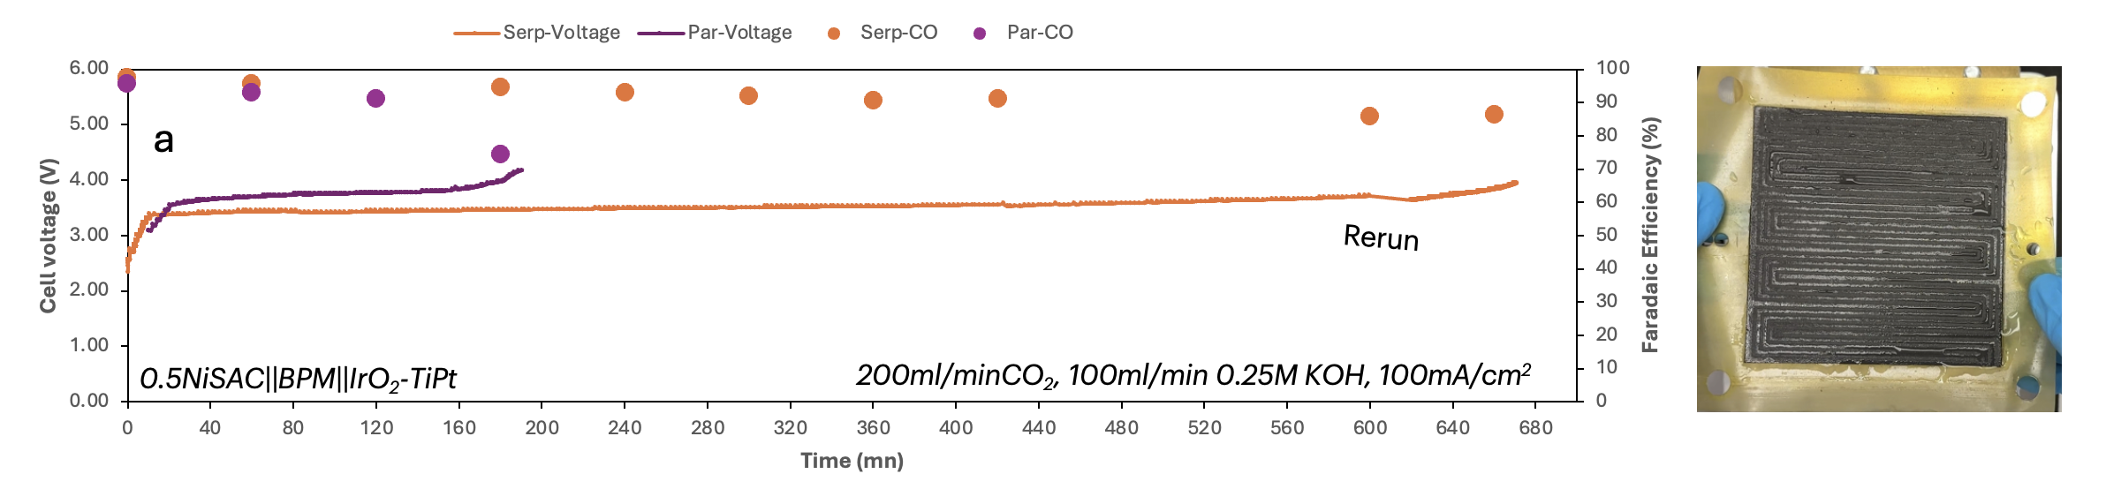
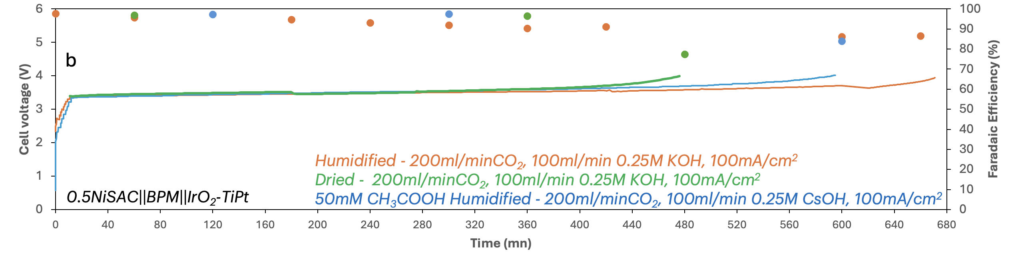
Figure 1. (a) Comparison of parallel and serpentine flow fields for CO₂ electrolysis of 0.5Ni-SAC in a 100cm² MEA electrolyzer under 200ml/min of CO₂, 100ml/min 0.25M KOH, and IrO₂-TiPt anode at 100mA/cm² and (b) different conditions.

Dried - 200ml/minCO₂, 0.25M KOH, 100mA/cm²
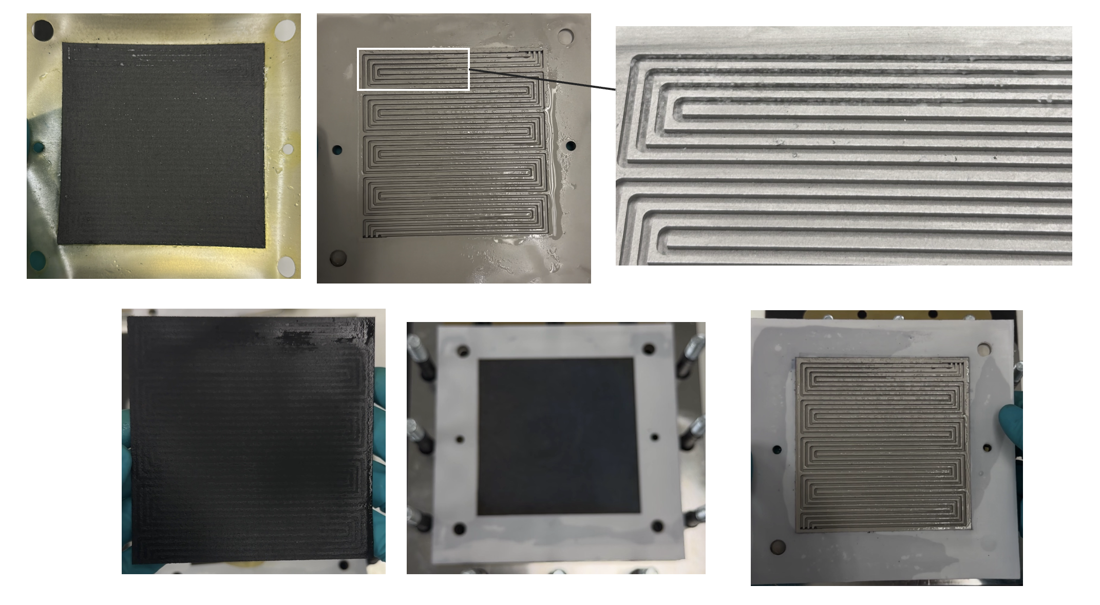
50mM CH₃COOH Humidified - 200ml/minCO₂, 0.25M CsOH, 100mA/cm²
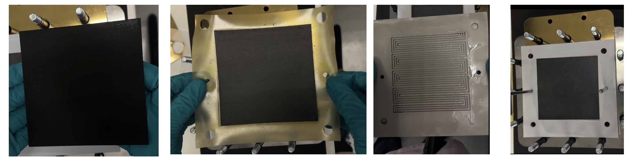

- Upcoming tasks
  - Solutions for fully preventing liquid leakage: Optimizing gasket material/thickness and compression load
  - 100cm² MEA electrolyzer – CO₂ electrolysis of serpentine-BPM system under a humidified 1000ml/min CO₂, 100ml/min of 0.25M KOH, and IrO₂-TiPt anode at 100mA/cm²
  - 100cm² MEA electrolyzer – CO₂ electrolysis of serpentine-BPM system under a humidified 500ml/min CO₂, 100ml/min of 0.25M KOH, and IrO2-TiPt anode at 100mA/cm²

